Together in Hope, Together for Christ
"For I was hungry and you gave me something to eat, I was thirsty and you gave me something to drink..." — Matthew 25:35–36
"He upholds the cause of the oppressed and gives food to the hungry..." — Psalm 146:7–9

Our Mission
To build relationships, equip, and serve together as the body of Christ with congregations and communities — moving all toward God’s vision of love, justice, hope, and peace.

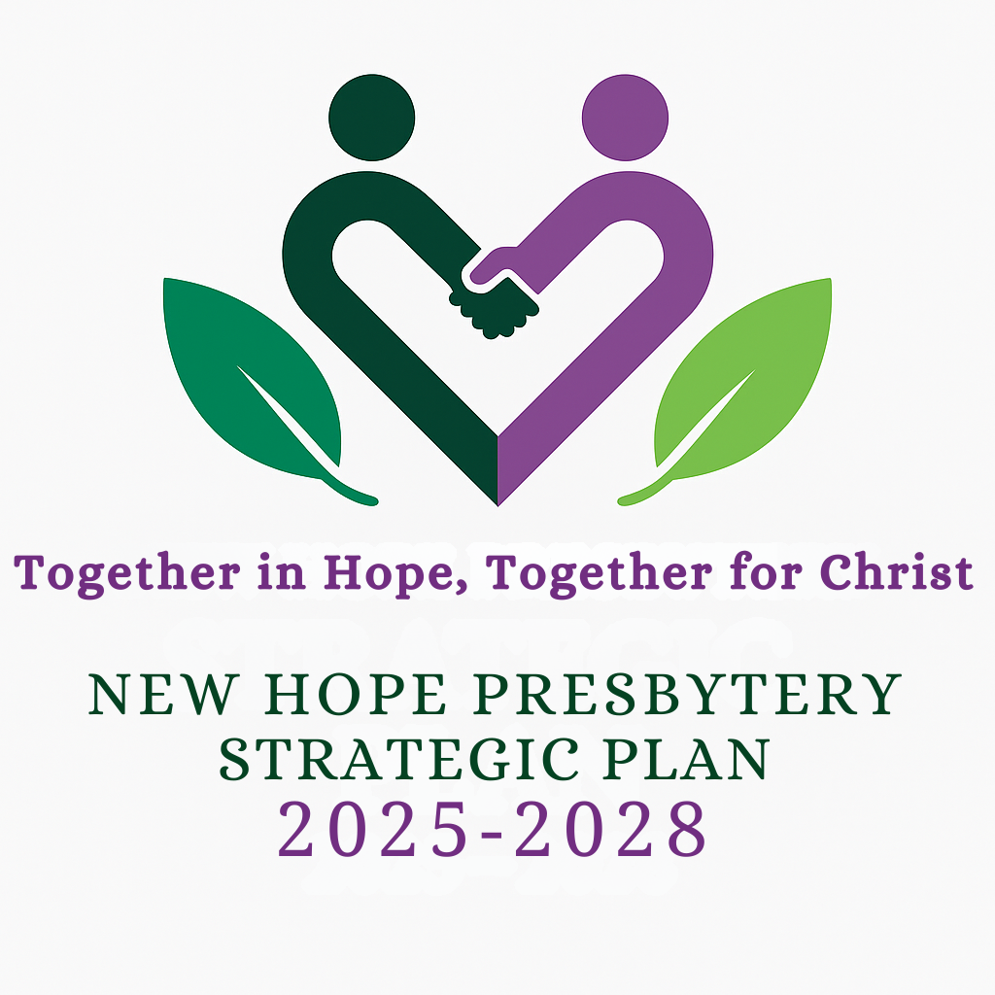
Strategic Goals
1. Build Connectional Relationships
Deepen collaboration among congregations through shared ministry, mutual support, and encouragement.
2. Equip Congregations for New Ministry
Provide innovative resources and training to reimagine how we worship, serve, and lead in today’s world.
3. Strengthen Faith-Based Identity
To implement and further the Matthew 25 principles of strengthening congregational vitality, dismantling structural racism, and eradicating poverty.

Rooted in Your Voice
This plan reflects the wisdom and hope gathered from Table Talks with presbytery leadership, focus groups across the Presbytery, and insights from the Pentecost Project and Holy Cow surveys.

Reaching for the Future
"For I know the plans I have for you, declares the Lord, plans to prosper you and not to harm you, plans to give you a future and a hope.” – Jeremiah 29:11. As we move forward in faith, trusting God’s promises, we commit to implementing these goals, building operational sustainability, and ensuring financial stability. Realizing this vision will require the collective dedication of the entire Presbytery of New Hope—from every congregation and across our 34 counties—as we step boldly into the future God is preparing for us.
Join a Task Force
We're forming teams to implement each goal — and we need your gifts!
Would you consider joining a Strategic Goal Task Force?

📧 Contact us: strategic@nhpresbytery.org; Visit https://nhpresbytery.org/together/

